**Lesson 13**

**I have**

**Singular object**

I have a mobile

Mery pas mobile hai

Mery pas laptop hai

Mery pas kitab hai

**plural object**

Mery pas kitaben hen

Mery pas chabi hai

Mery pas chabian hen

Mery pas ghari hai

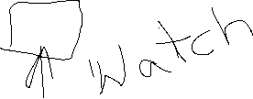

Also=bhi



Mery pas bhi garee hai



Mery pas bhi laptop hai

**I want/need**

I want a car



Mjhy garee chaiye

Mjhy paisy chaiye

Mjhy pani chaiye

Mjhy help(madad) chaiye

I need your time

Mjhy apka waqt(time) chaiye

Mjhy apki madad chaiye

I need advice from you

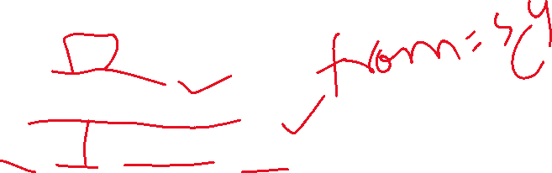

Mjhy apsy mashwara chaiye

I need your mobile phone for 2 mints

Mjhy apka mobile chaiye 2 mint k liye

Mjhy 2 mint k liye apka mobile chaiye

I need your trust(aetmaad)

Mjhy apka aetmaad chaiye

**I like**

Mjhy pasta passnd hai



Mjhy ayesha pssnd hai

I like you

Mjhy ap pssnd hen

Mjhy football khelna pssnd hai

Mjhy aam khana pssnd hai

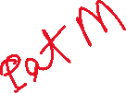

I like her smile/face(chehra)

Mjhy uska hansna pssnd hai

I like her sister

Mjhy uski behn/garee pssnd hai

Mjhy ye kitab bht ziada(very much) pssnd hai

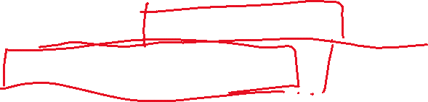

Mjhy ayesha ki dost pssnd hai